📄 Jenkins Job – Apache Logs Copy (copy-logs)

1️⃣ Login to Jenkins
- Open the Jenkins UI.
- Enter:
  - Username: admin
  - Password: ******

- Click Sign in.

2️⃣ Install Required Plugins
Go to:
Manage Jenkins → Plugins → Available Plugins
Search and install:
- ✅ SSH
- ✅ SSH Credentials
- ✅ Publish Over SSH

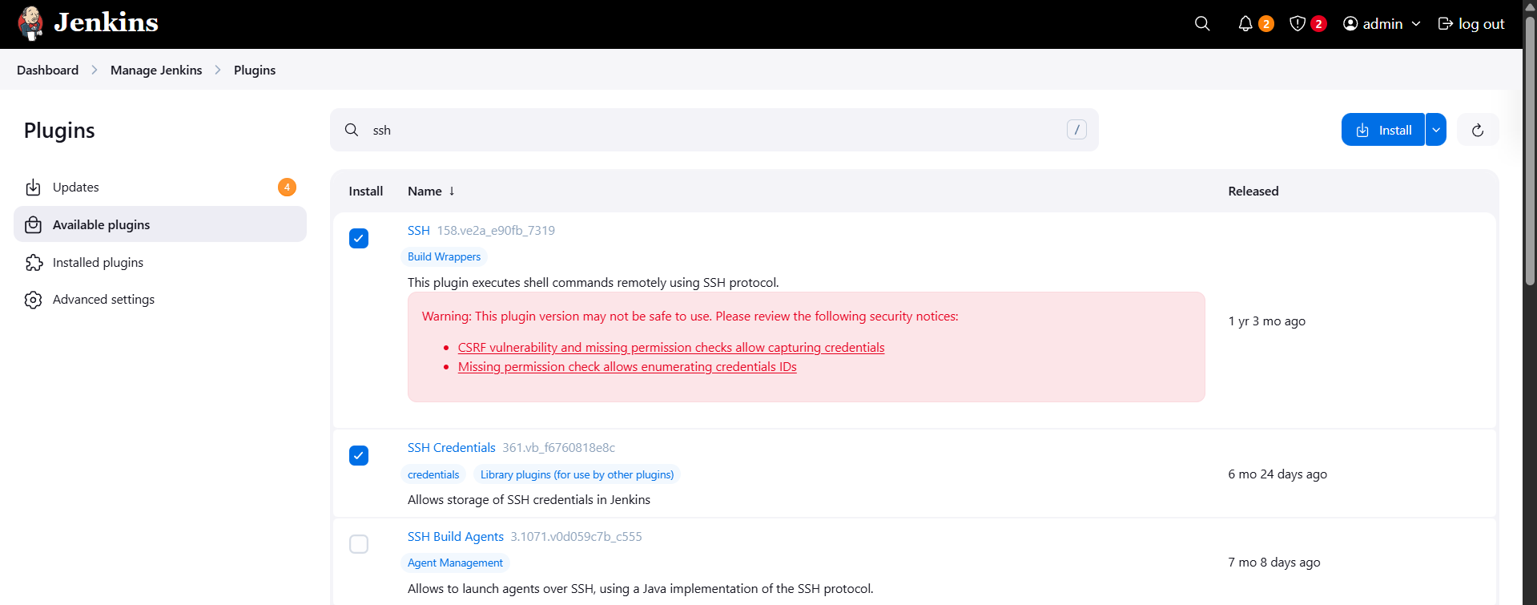
After installation:
- Click Restart Jenkins when installation is complete

- Wait until Jenkins comes back online.

3️⃣ Create Credentials for Remote Servers

🔹 Create Domain for App Server
Path:
Manage Jenkins → Credentials → System → Add Domain
- Domain Name: app01
- Click Create
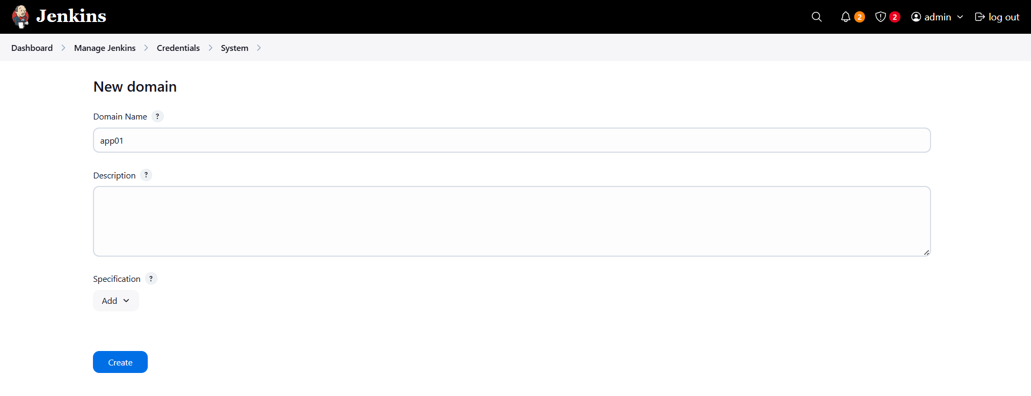
Now add credentials inside this domain:
- Kind: Username with password
- Username: tony
- Password: ********
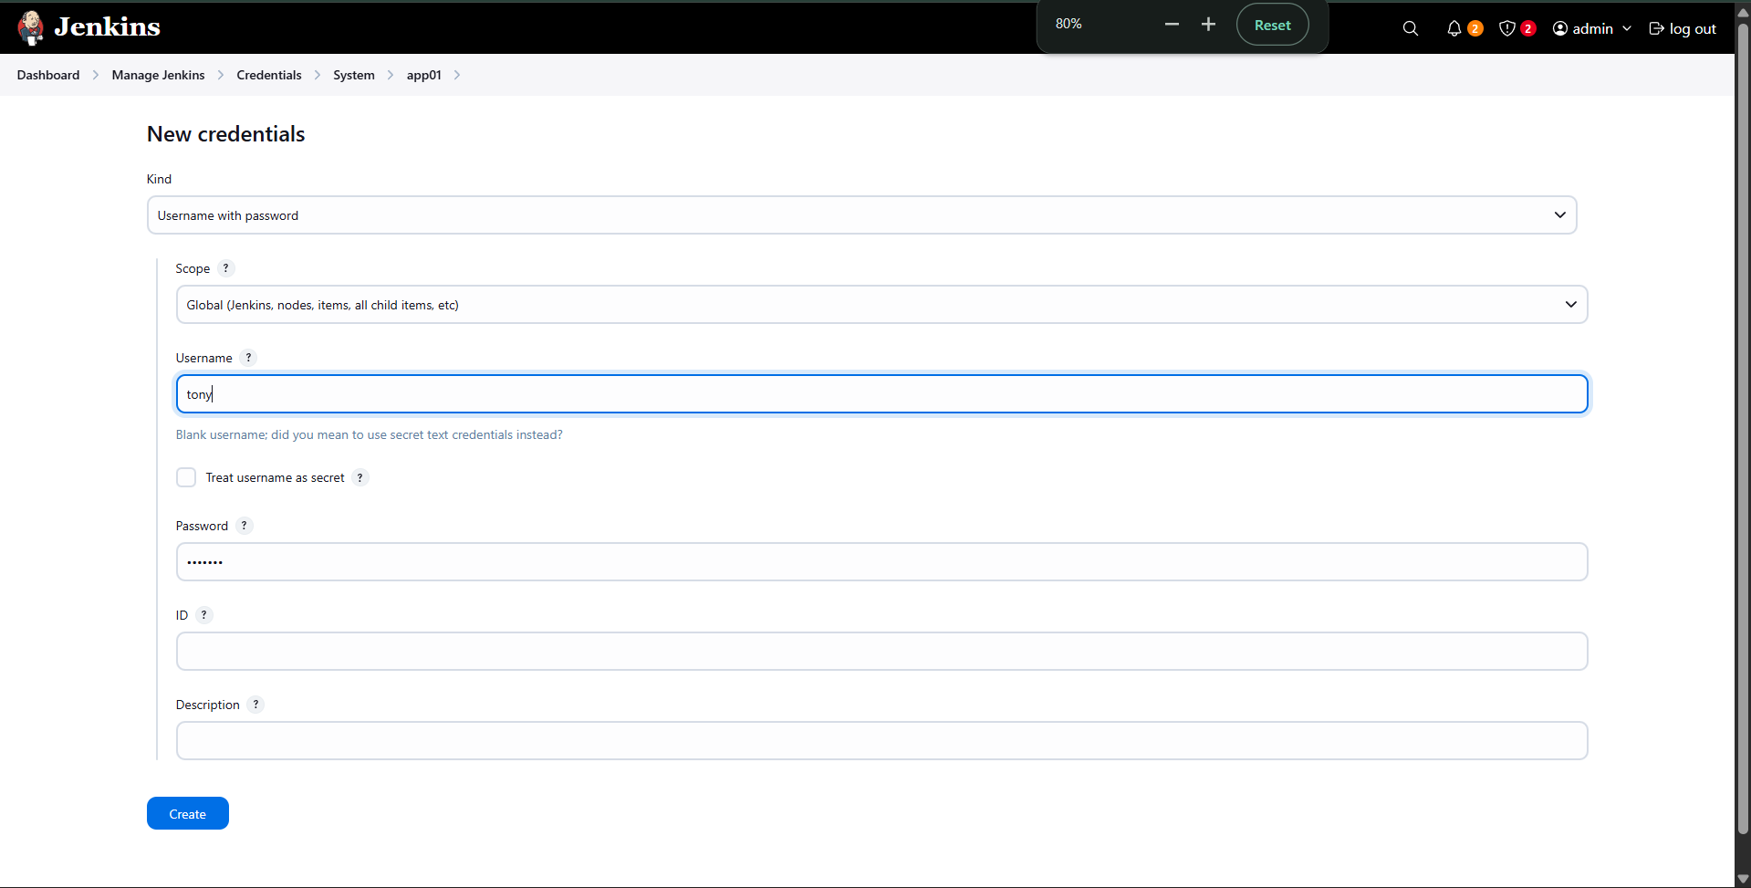
- Click Create

🔹 Create Domain for Storage Server
Again go to:
Manage Jenkins → Credentials → System → Add Domain
- Domain Name: ss01
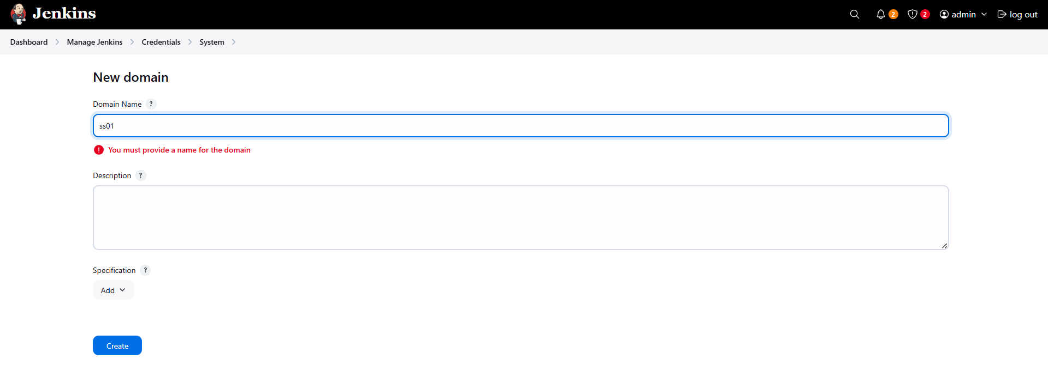
- Click Create
Add credentials:
- Kind: Username with password
- Username: natasha
- Password: ********
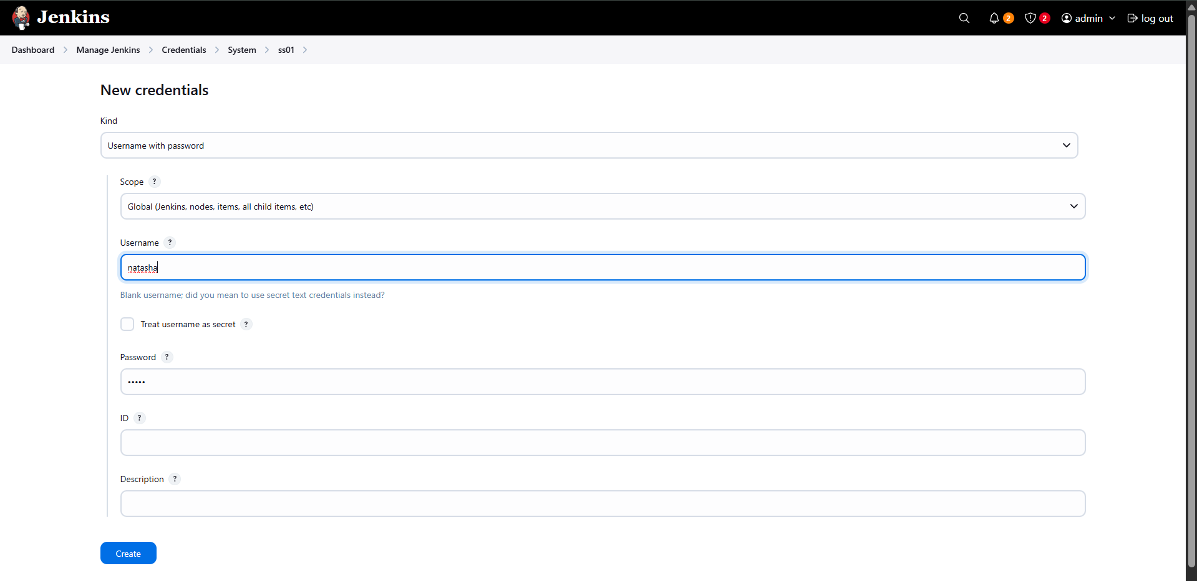
- Click Create

4️⃣ Configure SSH Remote Hosts
Go to:
Manage Jenkins → System → SSH remote hosts

🔹 App Server (Source)
- Hostname: stapp01
- Port: 22
- Credentials: tony
- Enable PTY
- Click Check connection → Successful
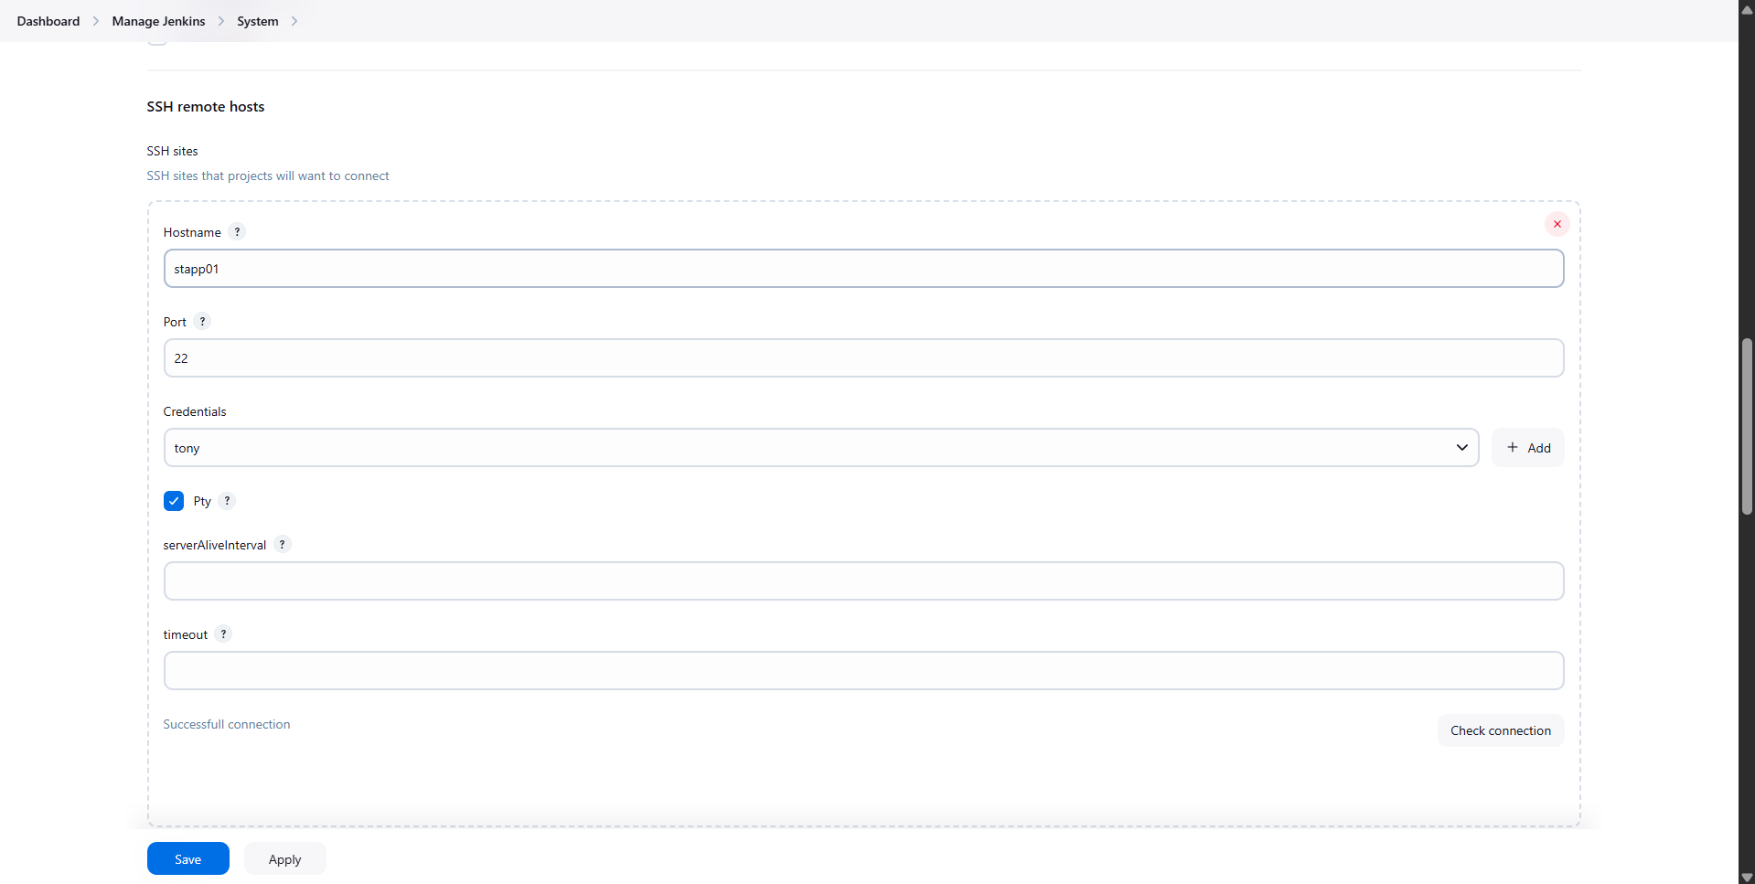
- Save

🔹 Storage Server (Destination)
- Hostname: ststor01
- Port: 22
- Credentials: natasha
- Enable PTY
- Click Check connection → Successful
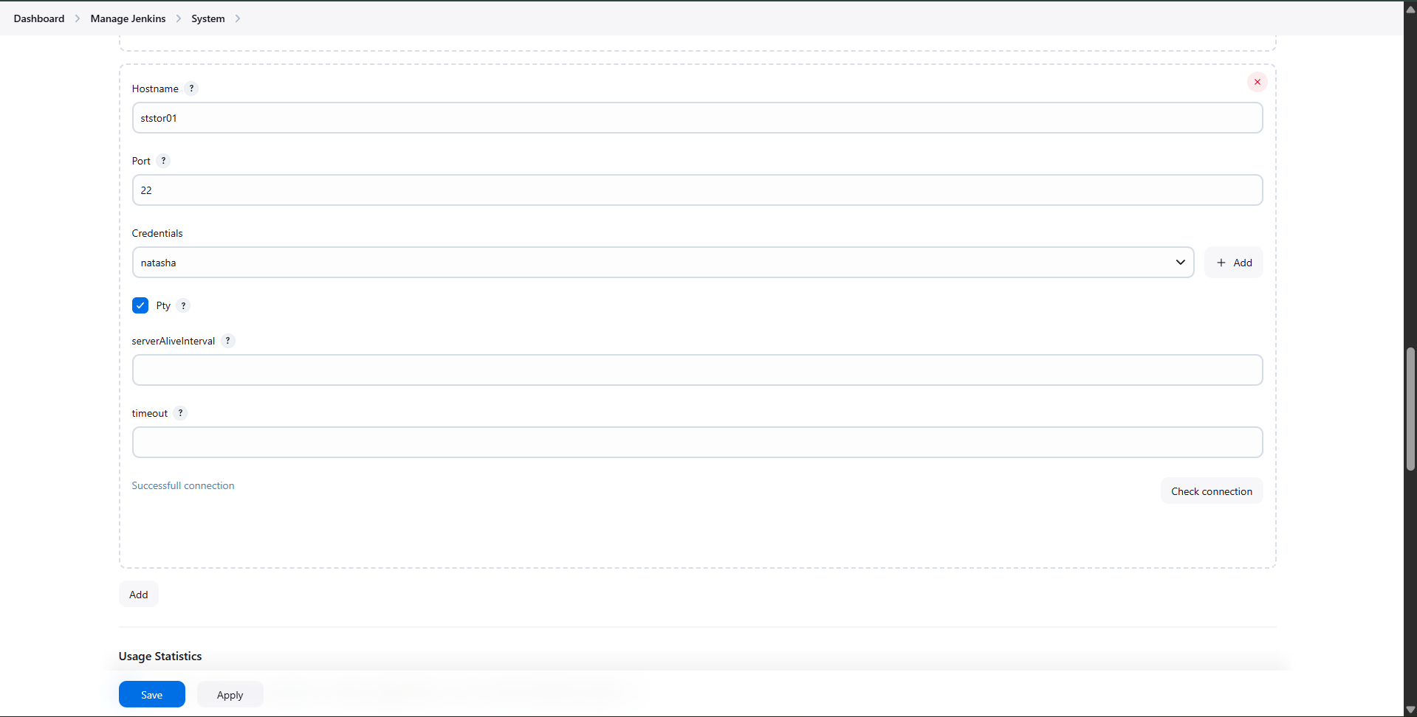
- Save

5️⃣ Create Jenkins Job
- Go to Dashboard → New Item
- Item name: copy-logs
- Select Freestyle Project
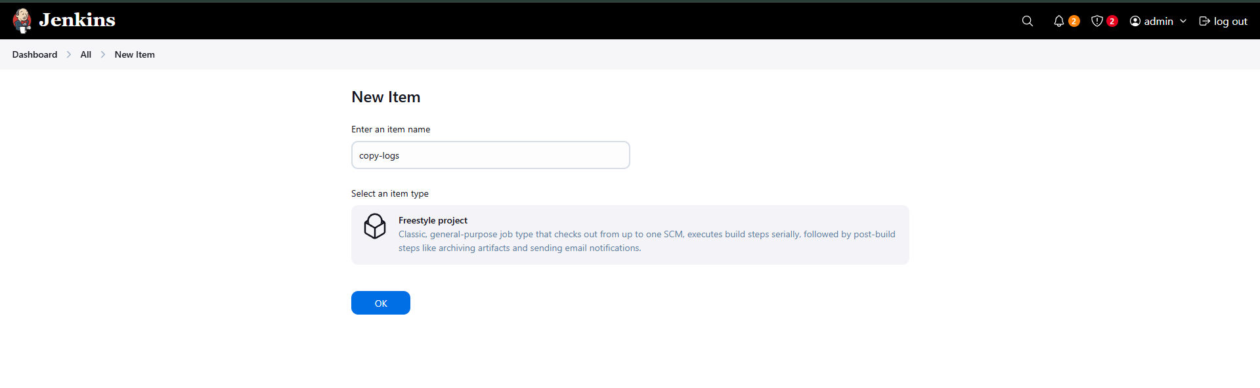
- Click OK

6️⃣ Configure Build Trigger (Scheduler)
Scroll to Build Triggers
✅ Select Build periodically
Enter:
*/5 * * * *
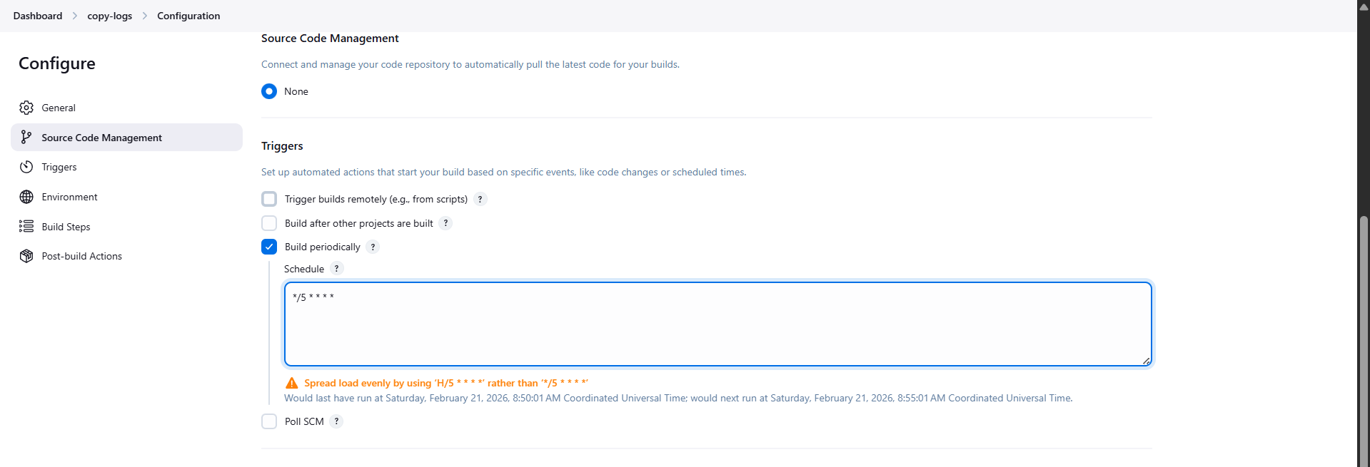
This runs the job every 5 minutes.

7️⃣ Add Build Step to Copy Logs
Go to Build Steps → Add build step
Select:
Execute shell script on remote host using ssh

SSH Site:
tony@stapp01:22

Command:
sshpass -p "********" scp -p -o StrictHostKeyChecking=no /var/log/httpd/* natasha@ststor01:/usr/src/security
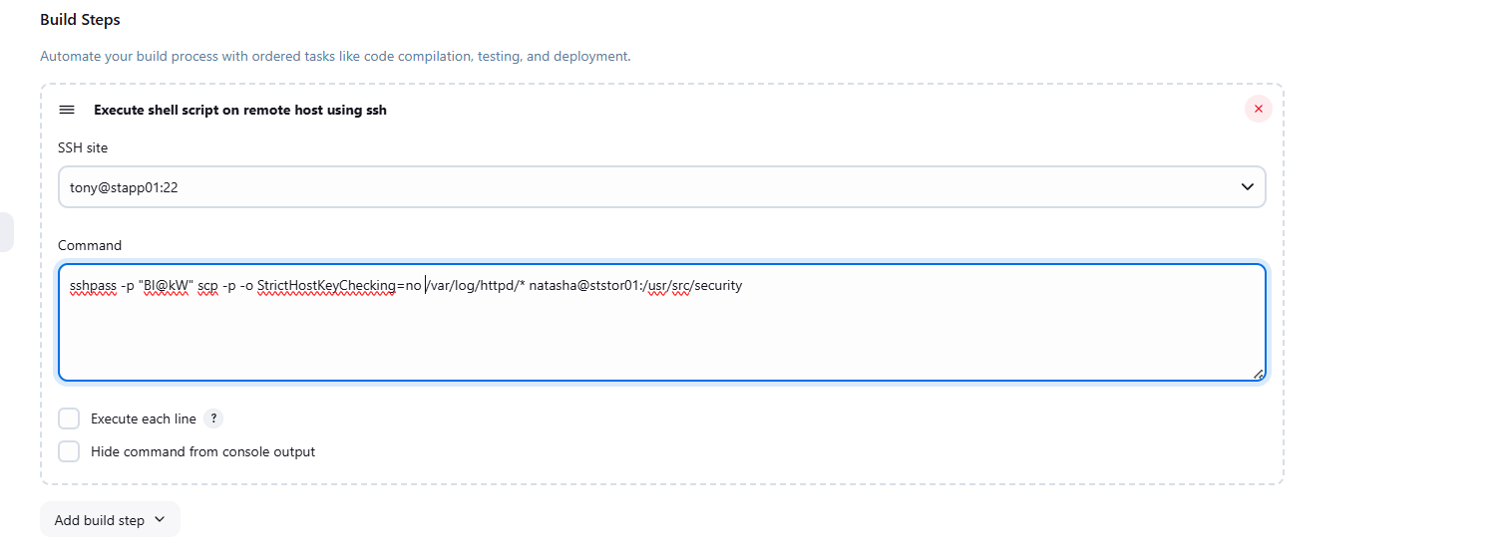
This command:
- Copies Apache logs from:
/var/log/httpd/ (App Server)
- To:
/usr/src/security (Storage Server)

8️⃣ Save the Job
Click Save.

9️⃣ Verify the Build
- Click Build Now
- Open Console Output
You should see:
[SSH] completed
Finished: SUCCESS
This confirms:
✔ Logs copied successfully
✔ Remote SSH execution worked
✔ Scheduled job is functional
